
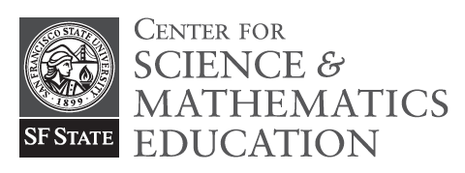

Register for Supplemental Instruction (SCI) Courses:

Get more out of your Science, Math, and Engineering classes!
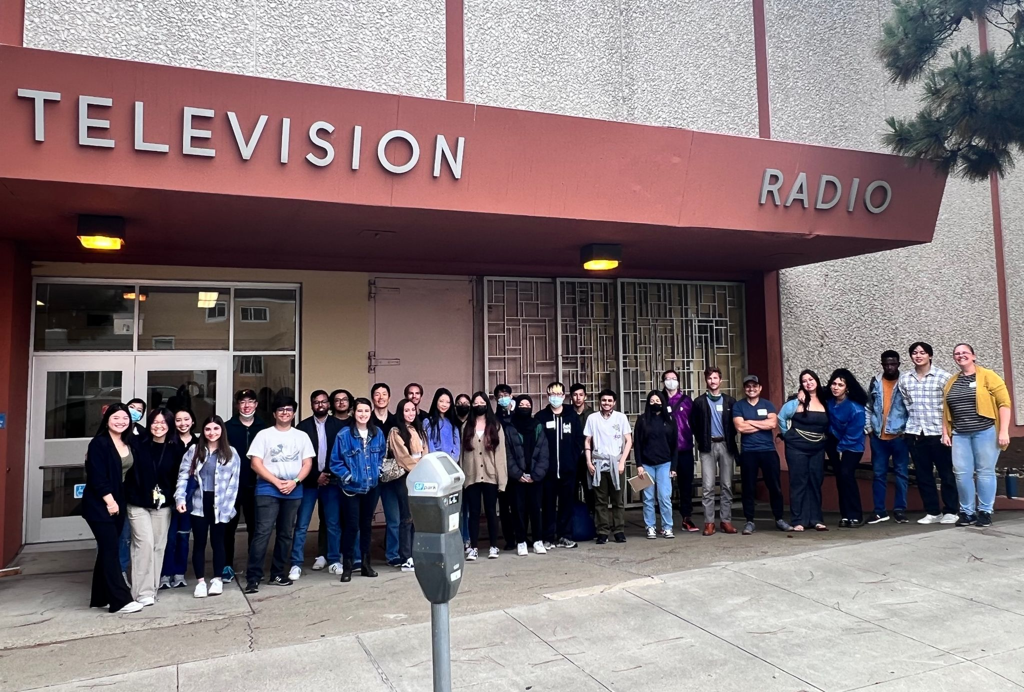
Learn how to study effectively and efficiently with your friends!

The 22-23 SI Team

We run SCI courses to support students in introductory biology, chemistry, math, physics, and engineering courses at SFSU. Check the schedule of classes for specific offerings each semester!

What is a SCI course? SCI courses are small 1-unit classes that meet once per week for an hour and 40 minutes. Students work in small groups on practice problems and activities to support their learning in the parent course with the help of two friendly undergrad facilitators. There are no exams or homework in a SCI course: grades are based on class participation and in-class activities, so you must be able to attend the class meeting. Note that SCI classes are in-person, on-campus.

Why take a SCI course? Students who take SCI and attend every week earn on average a half-letter grade better are twice as likely to pass the parent course on their first try! Additionally, SCI helps you solidify your understanding, plan your study time, learn new study strategies, and make friends with other students in your class and in your major.

How do I sign up for a SCI course? Search the class schedule for courses under the prefix “SCI”, and check that it matches your parent course (for example, students in CHEM 115 take SCI 115). Enroll like you would in any other class, or attend the next class meeting to get a permission number.

More questions? Email Jessica Fielder, at jfielder@sfsu.edu

Please include your name, student ID, and which SCI course(s) you are interested in the subject line.

Spring 2025 SCI Course Offerings

(times are subject to change, please check the class schedule for the most current information)

SCI Course | Parent Course | Meeting Time & Location
SCI 111.01 | PHYS 111 | M 12-1:40PM, CA 126
SCI 115.01 | CHEM 115 | T 6-7:40PM, CA 126
SCI 115.02 | CHEM 115 | W 10-11:40AM, CA 126
SCI 199.01 | MATH 199 | W 6-7:40PM, CA 126
SCI 205.01 | ENGR 205 | T 12-1:40PM, CA 126
SCI 215.01 | CHEM 215 | F 10-11:40AM, CA 126
SCI 220.01 | PHYS 220 | M 6-7:40PM, CA126
SCI 226.01 | MATH 226 | T 10-11:40AM, CA 126
SCI 226.02 | MATH 226 | W 4-5:40PM, CA 126
SCI 227.01 | MATH 227 | Th 6-7:40PM, CA 126
SCI 230.01 | BIOL 230 | Th 10-11:40AM, CA 126
SCI 305.01 | ENGR 305 | F 2-3:40PM, CA 126
SCI 333.01 | CHEM 233 | W 12-1:40PM, CA 126
SCI 335.01 | CHEM 335 | Th 2-3:40PM, CA 126

What do students think of SCI?

“Without this course I don't think I would have done as well just by studying on my own.” -SCI 215 student, Spring 2019

“SCI gave me confidence in my abilities.” -SCI 220 student, Spring 2018

“My group would give me different perspectives on a certain problem and would help me learn the concepts of the lessons better overall.” - SCI 226 student, Fall 2018

“Anytime there was a question the facilitators went above and beyond in order to make sure the concept in question was understood.” -SCI 115 student, Fall 2018

